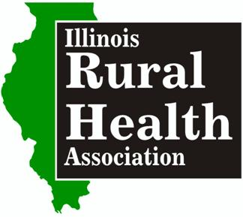

Illinois Rural Health Association
2018 Annual Educational Conference Schedule
Hilton Garden Inn • Champaign, IL • Aug 8-9th, 2018
Register at www.ilruralhealth.org

Wednesday, August 9th
8:00 a.m. – 10:45 a.m. – Exhibitor Set-Up
11:00 a.m. – 12:30 pm. - Registration, Exhibit Time, Box Lunch
12:30 p.m. – Opening Session - Annual Meeting & Best Practices in Rural Health Leadership
2:00 -2:45 p.m. – A SESSIONS
- Best Practices in Cybersecurity
- Making Illinois Safer: Identifying your Role in Injury, Violence, and Suicide Prevention
- Elements of An Emergency Plan & Annual Review Requirements
- How HIM & PFS Can Collaborate to Improve Revenue Cycle Efficiency
2:45 - 3:00 p.m. – Break & Exhibit Time
3:00 - 3:45 p.m. – B SESSIONS
- IHA-SIU Project ECHO – Tackling Hypertension and Opioids in Rural Illinois
- Cracking Communication Code: Words That Work
- Technology Enabled Approaches to the Opioid Crisis
- Rural Health Clinic Policies & Procedures
3:45 - 4:00 p.m. – Break and Exhibit Time
4:00 - 4:45 p.m. – C SESSIONS
- Southern Illinois Collaborative for Innovative Care Coordination: Phase I – Community Paramedicine Planning
- Cancer Prevention Through HPV Vaccination
- Health Choice Illinois Panel Discussion
- Why VoIP is Needed for 21st Century Healthcare
5:30 - 7:30 p.m. – Networking Reception – Papa Del’s, Complimentary drinks & buffet
8:15 - 11:00 p.m. “Conference After Party” with Comedian at Clark Bar’s Beer Garden Complimentary drinks & snacks

THURSDAY, AUGUST 9th
8:00 a.m. – 9:00 a.m. Breakfast Buffet & Exhibit Time
9:00 a.m. – National Rural Health Association Federal Update
10:00 a.m. – Door Price Drawings & Exhibitor Tear Down
10:15 – 11:00 a.m. – D SESSIONS
- Strategies for a Welcoming Age-Friendly Health Clinic
- Effective Recruiting Practices for Rural Providers
- Tabletop Emergency Preparedness Exercise

11:05 - 11:50 a.m. – E SESSIONS
- Employee Wellness Best Practices
- Building Healthy Illinois Rural Communities – Regional Approaches to Population Health
- Rural Health Clinic Survey & Certification
Noon - 1:20 p.m. –ANNUAL HEALTHCARE AWARDS LUNCHEON
1:20 - 2:00 p.m. - Closing General Session
- NFPA Standards Update: Active Shooter

